Operative Society Limited

# Application for Funding Policy

**Policy and procedures for the application for budget allocation of funds**

## 1. Purpose

To set out policy and procedures for volunteers to obtain funding for the conduct of villages, workshops, activity spaces, art, culture, infrastructure and other projects for DTE and or ConFest.

**2. Scope**

This Policy is intended for all applications for funding/budgets.

## 3. Link with other policy documents

This Policy links with and reinforces the Expenditure by Volunteers Policy and the Payment and Transfer Policy, available on: **http://www.dte.org.au/downloads**

## 4. Application Process

1. Be familiar with and follow the policy and procedures set out in DTE’s Expenditure by Volunteers Policy
2. Complete and submit an Application for Funding form including the Details of Intended uses of Funding form, available on: http://www.dte.org.au/downloads
3. Submit scans, copies or original tax invoices (or receipts if not GST applicable) for all expenditure made on DTE’s behalf.
4. Complete and submit a Summary of Expenditures (attached) form giving a detailed record of all expenditure.
5. For more information please email: **finance_group@dte.coop**
6. Submit completed applications to: **ocmail@dte.org.au and ccmail@dte.org.au**

The above forms and policies are available on: **http://www.dte.org.au/downloads**

## 5. Funding Application Outline

1. This Policy includes applications for villages, workshop and activity spaces, art and culture projects as well as infrastructure and other projects for DTE and/or ConFest. All funding applications are subject to the approval of the ConFest Committee, Organising Committee, ConFab Committee or the Board.
2. Funds are limited and will be allocated on merit. All decisions by the relevant Committee or Board are final.
3. Where buying or hiring equipment/services from members of your crew, DTE members or ConFesters is proposed, this must be noted on your application form and comparable quotes are to be provided where possible.
4. Selling or trading of goods or services other than as an official stall in the Market is not permitted and doing so may result in the removal of the individual or project concerned from ConFest.
5. For proposed purchase/hire of items costing $500 or more, alternative quotes/prices must be provided (where possible) with the funding application.
6. All items costing more than $100 that you intend to purchase must be listed in the application, and an inventory kept of items in the care of the space/project that are owned by DTE, this list is required from each funding recipient and needs to contain full descriptions, serial numbers and warranty information where applicable.
7. All expenditures must be supported by a tax invoice, or in the case of secondhand or non-taxable items, a receipt or other substantial proof of purchase document.
8. DTE cannot accept bartering processes as it has no legally viable means of establishing proof of purchase for tax and accounting purposes.

## 6. Applicants for Funding need to

1. Understand that all items purchased with DTE funds are and remain the property of DTE, caretakers of any of these items who decide to cease their involvement with DTE and ConFest must make reasonable efforts to return those items to those taking over the role/project/space, or to DTE, whichever is most applicable. Failure to do so may result in legal action.
2. Be aware that anyone owing in excess of $500 of funds or tax invoices/receipts to DTE will not be granted advance funding. Those still owing funds or receipts under $500 may only be considered for a budget approval on the basis of reimbursement on provision of tax invoice/s only.
3. Be familiar with the conditions for use of DTE funds and the processes for returning tax invoices.
4. Submit all tax invoices and receipts (or acceptable scans or copies) together with your completed Summary of Expenditures at ConFest or within 14 days of completion of the project.
5. Understand that budget overruns will only be approved in exceptional circumstances.

## 7. Use of Funding

1. Alcohol, tobacco or other personal items are not to be purchased with DTE funds.
2. Food may be purchased with DTE funds for feeding working volunteers, and for approved public events at ConFest and/or ConFab gatherings.
3. DTE does not cover costs for personal travel to ConFest, including fuel, food or other. For transporting items for your project involving trailers, and/or items of significant weight/size to ConFest, travel/transport costs may be allocated, these must be included in detail in your budget application.
4. Fuel expenses may be allocated for those traveling to participate in working bees or similar.

## 8. Submitting Tax Invoices

A tax invoice is a receipt or proof of purchase document that shows the amount of GST paid for taxable items. Refer to <https://www.ato.gov.au/Business/GST/Issuing-tax-invoices/>

Funding recipients are to retain a copy or the original receipts/tax invoices for their own records and in case of future query. All tax invoices/receipts to be submitted within 14 days of completion of the project. They can be submitted: **a)** As scans by email to: **finance_group@dte.coop**

1. By registered post to:

**Down To Earth (Vic) Co-Operative Society Limited, P.O. Box 295, Brunswick East. Vic. 3057**

1. Via digital or other means to be discussed with the Finance Group **finance_group@dte.coop**

## Acknowledgment

This Policy has been based on the work of the many volunteers who have contributed to this area in the past and their work is acknowledged. How we have thought and worked in the past can play a powerful role in shaping the present.

## operative Society Limited Application for Funding

**Name of applicant/s:** ……Organising Committee...........................................................................................................

**I hereby apply for a budget of $**…20,000.00……………..**for project/space: Payments of regular accounts**..........

### Please describe the purpose and/or philosophy of the project/space

……………………This is the first quarter payment of 15,000.00 and $5,000.00 contingency to have funds available to pay accounts as they come due in the first quarter of 2023/2024.…………………………………………………….

……………………….....................…………………………………………………………………………………………………

……………….....................…………………………………………………………………………………………………………

……….....................………………………………………………………………………………………………………………….

....................………………………………………………………………………………………………………………….............

**Should a budget be granted, it can be accessed in two ways (tick which is applicable):**

**First way:** Spend your own money to a limit within the funding amount approved, then request reimbursement after your project is complete by submitting your receipts/tax invoices. If your project was not ConFest specific, submit within two weeks of project completion. Provide your banking details for reimbursements.

**Second way:** If your application is successful, money will be transferred to you on a DTE debit card. Once your project is complete, submit your receipts/tax invoices in date order

### Do you have a D.T.E Debit Card? (please circle) Yes / No

If No please contact **finance_group@dte.coop** to arrange for a debit card to be issued to you.

**Applicants for funding must sign the following declaration:**

**I agree to comply with the conditions of the Application for Funding Policy set out overleaf. I agree that the funds will not be used for purposes other than those described by me in this application. I agree to provide receipts/tax invoices as evidence of all expenditure and understand that failure to do so may result in debt recovery and/or legal action.**

**Full Name of applicant** (print) …Malcolm Matthews…………….……………………………………......................

**Identification** (eg, Drivers License #)………….………………………..………**PH#**…..………………………......................

**Contact Address/s**……………………………………………………….………………………………...................................

…..…………………………………………………………….**Email** …..……..…………………………………………...............

**Signature of applicant**…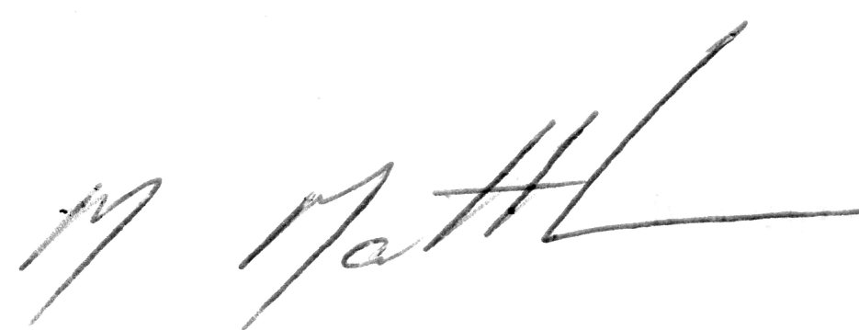……...................... **Date 20** / 6 / 2023

**Signature of witness** ……………………………………………………………………………………………........................

**Full name of witness** (print) ………………………………………………..................... **PH#**…..…………………………....

## operative Society Limited Application for Funding

**Details of Intended Uses of Funding**

The funding applied for by………………………………............................................………(name of applicant) will be used for the purposes listed on this document. Note: Items over $100 value must be listed individually, and please provide alternate quotes/prices for items over $500 where possible.

The funds cannot be used for any other purpose/s except those detailed by you in this application and approved or adjusted by the relevant committee. All items purchased with DTE funds are and remain the property of the Down To Earth Co-operative Society. Please complete and submit this form with your Funding Application.

If any of the intended expenditures involve a cost for hire/purchase/service to a member of your project/space, DTE, or a ConFester, please give details and include two comparable quotes/estimates:

............................................................................................................................................................................................ ............................................................................................................................................................................................

|  |  |
| --- | --- |
| **Item/Category** | **Expected Cost** |
|  |  |
|  |  |
|  |  |
|  |  |
|  |  |
|  |  |
|  |  |
|  |  |
|  |  |
|  |  |
|  |  |
|  |  |

### Anticipated date for completion of your project: / /

**Signed**…………………………………………………………………..… (Applicant Signature) **Date / /**

operative Society Limited

# Summary of Expenditures

Please list, and submit all your tax invoices, receipts and other proof of purchase documents with this form within two weeks of the end of the project, retain copies for your own records and in case of future queries. Please use extra pages if needed.

**Project/Space:**………….......…………………………… **Amount:**…………………. **Date Approved** / / **Project Facilitator Name:**……………………………………………………**Ph#**………………………………………............

**DTE Debit Card Holder:**…………………………………………………...…**Ph#**……………………………………...............

|  |  |  |  |  |  |
| --- | --- | --- | --- | --- | --- |
| **Date** | **Item/Category** |  |  | **Total Cost** | **GST** |
|  |  |  |  |  |  |
|  |  |  |  |  |  |
|  |  |  |  |  |  |
|  |  |  |  |  |  |
|  |  |  |  |  |  |
|  |  |  |  |  |  |
|  |  |  |  |  |  |
|  |  |  |  |  |  |
|  |  |  |  |  |  |
|  |  |  |  |  |  |
|  |  |  |  |  |  |
|  |  |  |  |  |  |
|  |  |  |  |  |  |
|  |  |  |  |  |  |
|  |  |  |  |  |  |
|  | |  | **Total** |  |  |